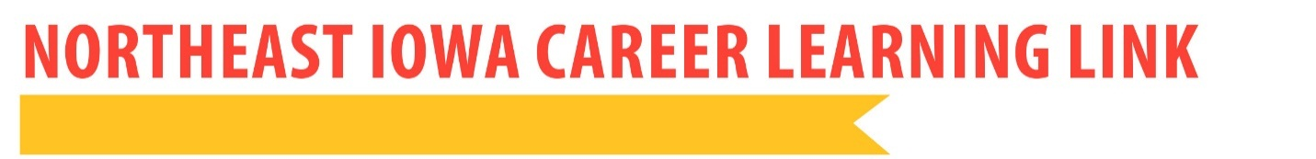
YOUTH CAREER CONNECT PROGRAM OVERVIEW

PURPOSE:
- Purpose: expose students to high-demand career areas and get them on the pathway to career and educational success beyond high school
- Save TIME AND MONEY by knowing what path to take after high school
- Students will work with a Career Coach to find the right post-graduation plan, whether it be to attend a four-year institution, a two-year institution, or enter directly into the work force.
- Be part of a nationally-recognized, high-visibility Department of Labor grant that can showcase our great students in Northeast Iowa!
YCC might be a good fit for you if you’ve asked:
*What career is a good fit for me and how can I use my passions and talents?
*What NICC college credit classes should I take in high school?
*How much will it cost to go to a 2 year college vs. a 4 year college?
*How will my college-credit classes from high school transfer to college?
*How do I apply for college? What do I need to know about financial aid?
*How can I gain experience in my career path before I graduate from high school?

REQUIREMENTS:
- Must be enrolled by fall semester of Junior Year
  - Fill out application and obtain required signatures
- Be interested in a career in one of these five pathways – Advanced Manufacturing, Information Technology, STEM (science, technology, engineering, math), Business/Finance, Health Occupations
- Attend a student-parent orientation with CLL staff
- Commit to two years of participation
- Complete one college credit class both junior and senior years
- Participate in a job shadow
- Complete the college credit Pre-employment Strategies course
- Meet with a Career Coach at least twice during each school year

BENEFITS:
- College-credit courses appropriate for specific education/career interests junior and senior years
- One-on-one Career Coaching:
  - A clearly defined future career or education path
  - Development of career goals
  - Enhancement of career-based skills
  - Assistance with college application process
- Pre-employment Strategies course
- Job shadowing experience
- Opportunities for tours, speakers, and leadership activities
- The option to participate in an Internship and/or Mentoring program
- Graduate with college credits that will benefit future education/career plans
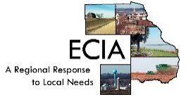
- Be recognized at senior awards night as a successful YCC participant
To participate in YCC, please contact your school counseling office for application materials or email Holly Maurer at maurerh@nicc.edu.
This workforce solution is partially funded by a $2,784,360 U.S. Department of Labor Employment and Training Administration Youth CareerConnect Grant.
Northeast Iowa Career Learning Link materials by Northeast Iowa Community College are licensed under a CC-BY4.0 International License.
A member of the Iowa Intermediary Network.

